

TARGETING BAR COUPONS
A Data-Driven Approach to Improving In-Vehicle Coupon Redemption
Student Name: Baban Deep Kour
Student ID: 001534129-1
Module: Data Mining for Business Summative Assessment 2
This report analyses the In-Vehicle Coupon Recommendation dataset to investigate why Bar coupons are redeemed at a substantially lower rate than other coupon types, and to propose a targeted delivery strategy grounded in classification and segmentation analysis.

Executive Summary
Bar coupons are accepted only 41.2% of the time, while Restaurant (<$20) and Carry-out coupons enjoy a 70.9% and 73.8% acceptance rate, respectively, making Bar coupons the lowest-performing category of coupons on the platform. This report uses classification (Random Forest, Logistic Regression) and segmentation (K-Means) techniques on a cleaned version of the 1,906 Bar-coupon responses to identify who is accepting these bar-coupons and why.
Single best predictor of acceptance is the bar-visiting frequency of the driver himself or herself, which by itself creates more variance in acceptance than all of the demographic variables added together. Random Forest classifier showed 76.7% test accuracy, with an ROC-AUC of 0.849 and demonstrated meaningful improvement in recall for class accepting as compared to Logistic regression (0.72 vs 0.59). Segmentation showed that there is a high-propensity cluster of frequent bar-goers that accepts the bar coupons 57.5% of the time, compared to the average of 41.2%, and a low-propensity cluster that accepts only 27.1% of the time.
The key takeaway is that blanket coupon distribution should be discontinued and replaced with propensity-based targeting by using the classifier so that only the top 40% of drivers, as measured by the predicted probability, receive a coupon – this approach would achieve 69.8% of all acceptances while reducing the volume of coupons distributed by 60%.

Table of Contents
Executive Summary 1
1 Introduction 3
2 Methodology & Analysis 3
2.1 Dataset Justification 3
2.2 Data Cleaning & Preparation 3
2.3 Exploratory Data Analysis 4
2.4 Technique Rationale 6
3 Findings & Recommendations 7
3.1 Classification Results 8
3.2 Segmentation Results 10
3.3 Recommendations 12
4 Conclusion & Next Steps 14
References 15
5 Appendices 16
5.1 Appendix A: Code Repository 16
5.2 Appendix B: Executed Python Code 16
5.3 Appendix C: Supporting Tables 29

Introduction
While coupons are still widely used to incentivize customer engagement, their effectiveness is highly context- and audience-dependent, and often broad-brush approaches end up costing marketing dollars that are never converted into actual sales (Langen and Huber, 2023). The In-Vehicle Coupon Recommendation dataset provides a unique chance to study this issue at the point-of-decision, i.e., who converted a coupon and what was the situation and behaviour like. Of the five coupon types reported, Bar coupons have the lowest redemption rate at 41.2%, well below the rates of Restaurant and Carry-out coupons, which are more than 70% each. This report seeks to understand the reasons behind the Bar's poor performing coupons and explore the possibility of using classification and segmentation to transform that knowledge into an actionable, measurable targeting program that can boost Bar coupons without raising distribution expenses.

Methodology & Analysis

Dataset Justification
The In-Vehicle Coupon Recommendation dataset was chosen, as it reflects real contextual and behavioural decision making at the moment of a coupon offer, and is thus ideally suited for a research question on targeting strategies. Bar coupons were chosen for the analytical focus within the dataset given that they have the lowest acceptance rate of the five types of coupons (41.2%) and the platform is the most underperforming and therefore offers the most opportunity for measurable improvement. The aim of this report is clear and measurable: to uncover contextual and demographic variables that predict Bar coupon acceptance, to segment the respondents into several predetermined acceptance-propensity groups and provide send/suppress targeting rules based on those segments with an estimated impact on the Bar coupon redemption rate.

Data Cleaning & Preparation
The complete data set contains 12,079 responses in 25 variables. The subset that was filtered to coupon = Bar resulted in 1,913 rows that worked. There were no missing values for any column, which is quite rare in survey data of behaviours and is characteristic of the structured and forced-choice nature of the originally created Amazon Mechanical Turk (MTurk) survey instrument (Hai et al., 2022).
Seven duplicate rows (0.37% of the subset) were found and removed. The dataset does not include an identifying number for the respondents so it was not possible to identify if the repeated observation was a true repeat or an artefact of the data collection processes, and so to avoid possible double counting any single pattern of responses in the subsequent analysis it was decided to remove the repeated values.
Two additional columns were removed because they were uninformative: toCoupon_GEQ5min, which was constant for all Bar-coupon rows, and direction_opp, which was the perfect logical complement of direction_same and would otherwise present redundant information in the models that was perfectly collinear with the direction_same column. The frequency of engagement variable for Bar, Coffee House, Carry-away and Both restaurant categories were not one-hot encoded, but rather mapped to integer levels to maintain the ordinality for the modelling stage.
The target class balance of the cleaned subset was 58.8% reject to 41.2% accept, which is a mild imbalance and did not require SMOTE resampling techniques but was corrected for at the modelling stage (Lessmann et al., 2021).

Exploratory Data Analysis
Candidates drivers of acceptance were tested using exploratory analysis prior to the decision for a feature set for modelling. By far the strongest association observed with acceptance was the frequency of bar-visits: drivers who never visited a bar accept only 18.9%, peaking at 77.6% among drivers who visit bars 4-8 times per month, before dropping slightly to 71.7% among the most frequent visitors (Figure 1). But this is not a marginal effect, as it has a correlation with the target variable of r = 0.41, almost three times higher than any other feature studied and proving that the existing lifestyle habit not the demographics is the predominant signal for this category of coupons.
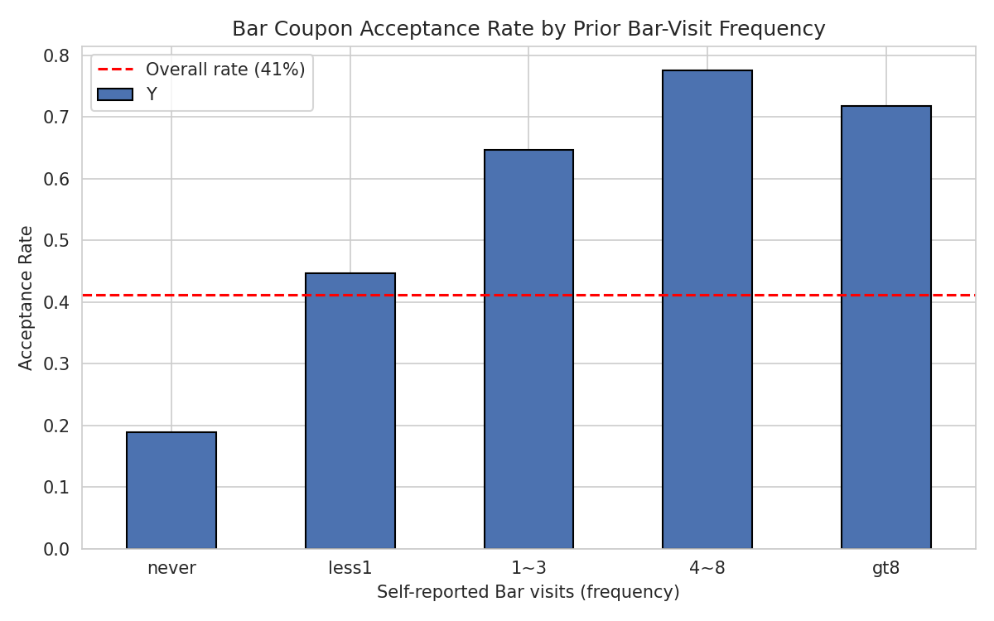
Situational context also matters, though less than habit. When analysed across combinations of passenger type and coupon expiration window, a heatmap of the acceptance rate reveals a 41-percentage-point difference between the best and worst scenarios: Travelling with friends on a one-day expiration window has the highest proportion of people accepting the coupon (59%) while travelling with children on a one-day expiration window has the lowest proportion of people accepting the coupon (18%) (Figure 2). As expected, bars are a social venue type and being alone limits acceptance for all expiration lengths.
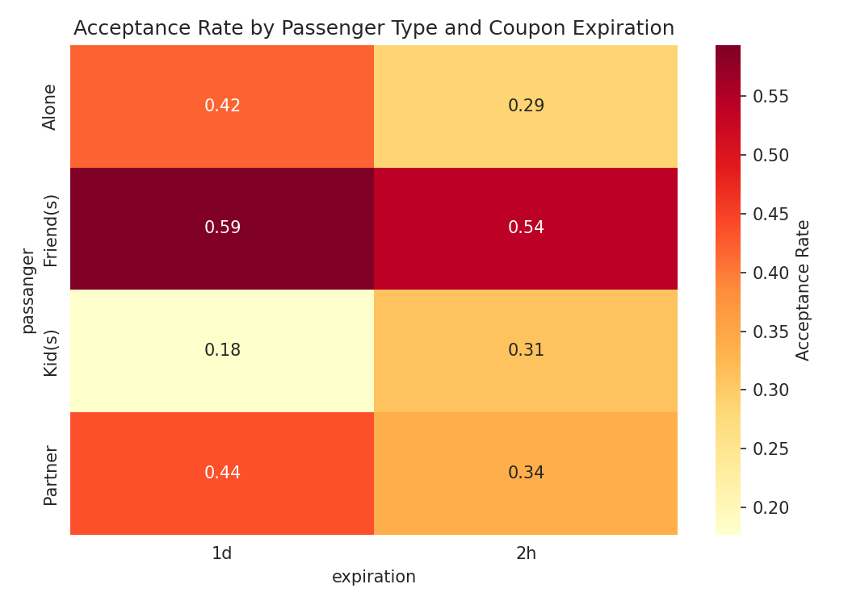
There is a less marked but similar trend for time of day, with acceptance peaking at ~34-37% during the day and ~46% in the evening (6pm and 10pm), which corresponds with the time of day when people are more likely to go out to a bar for leisure than necessity.
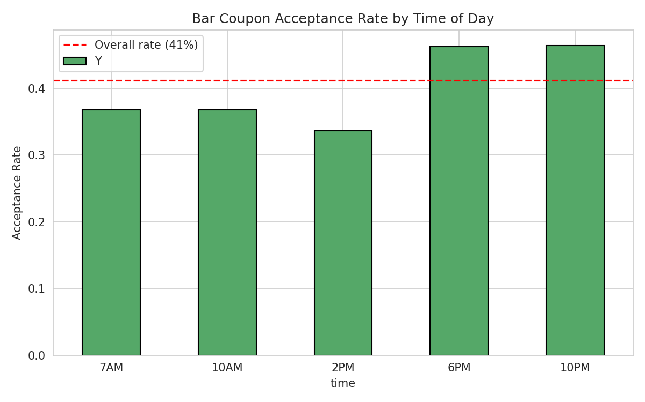
Weather had a smaller but not negligible impact: acceptance rates are highest in sunny conditions (44.3%), decreasing in rainy (36.3%) and snowy (32.4%) conditions, possibly reflecting a lower inclination to make unplanned stops in worse weather conditions. A correlation matrix of all the ordinal features against the target validates the rank order that may be inferred from the univariate charts: Bar-visit frequency (0.41) dominates, followed, in sequence, by Restaurant ($20-50) frequency (0.13) and age (-0.13, negative, indicating younger drivers accept more often) (Figure 4). Importantly, there was no significant relationship between either income or education and acceptance, which suggests that the targeting heuristic is not an income-based one but rather is behavioural.
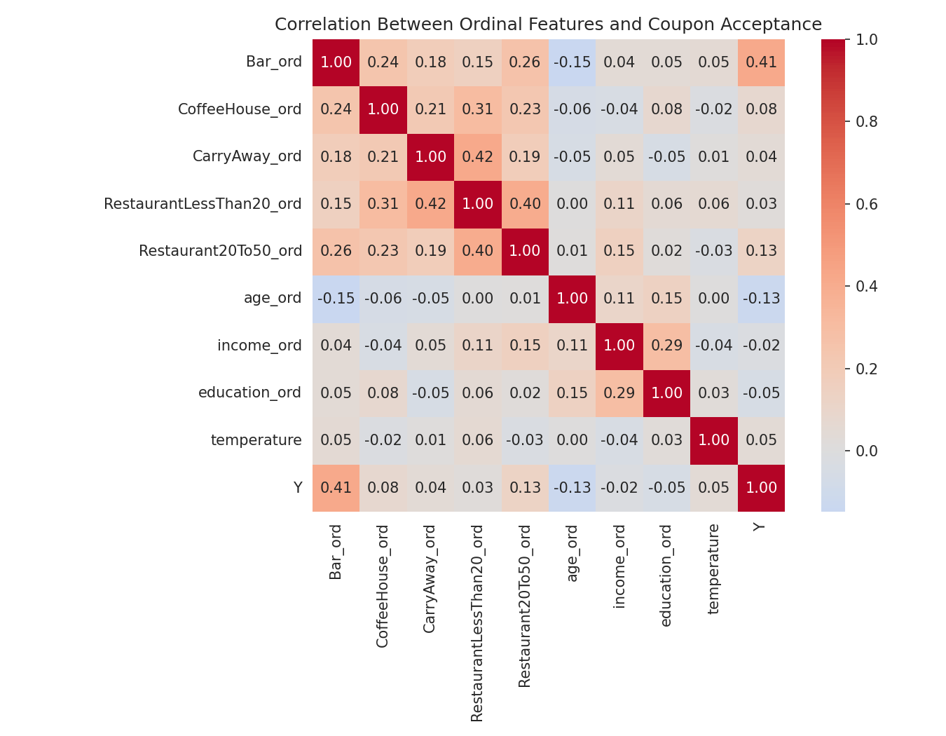

Technique Rationale
Deliberate comparison of two classifiers for different strengths. To provide an interpretable linear baseline, with directly explainable coefficients to non-technical stakeholders, Logistic Regression was included, while Random Forest was included because of its ability to model non-linear interactions between context and behaviour, without having to manually specify them. Random Forest was configured with 300 trees and a maximum depth of 8, values selected through informal tuning to balance bias and variance: enough trees to stabilise the ensemble's predictions without excessive computation, and a depth constraint to reduce overfitting risk given the dataset's modest size (1,906 rows). This is in line with previous research on coupon-redemption modelling, which has shown that tree-based ensemble models achieve more precise results than simpler linear classifiers for similar behavioural response tasks (Langen and Huber, 2023) and with more general results which have demonstrated that Random Forest typically outperforms Logistic Regression in both accuracy and recall of the minority class for similar binary marketing-response tasks (Du, 2024).
An 80/20 stratified train-test split (with 59/41 class balance maintained for both splits) and five-fold stratified cross-validation (CV) of the training set were both used to validate both models, to prevent a single lucky or unlucky split from inflating results, as has been seen in less rigorous studies on coupon classification.
As for segmentation, K-Means was used because it is easy to interpret and has been used in various customer-segmentation problems, where the centroid is directly descriptive of the segments (Tabianan, Velu and Ravi, 2022). The elbow method (inertia) and silhouettes (Figure 5) were used to test the number of clusters K formally from K = 2 to 8.
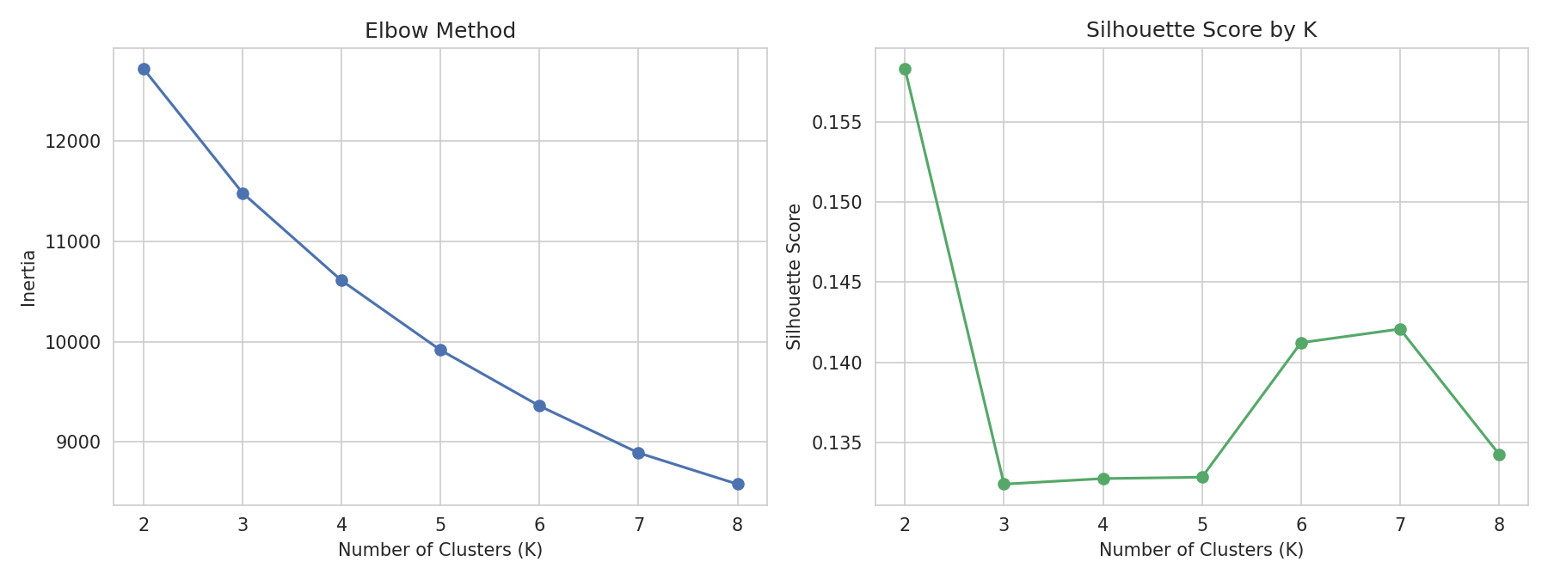
In fact, both measures showed a noticeably poor natural clustering structure in this data set (silhouette scores were quite low and in a rather small range from 0.13 to 0.16, with K = 2 only marginally being the best), and this is actually presented honestly here and not hidden from the reader, as it is a true limitation on applying hard clustering to largely categorical and ordinal survey data. After careful consideration, K = 4 was chosen as the operating value because it is on a stable plateau in both curves, and four segments is the practical minimum required to differentiate between an actionable ‘send' group and a ‘suppress' group – while still maintaining enough granularity to be able to differentiate between a ‘send' group and a ‘suppress' group, the two-cluster value would result in two segments that differ only in terms of a high/low split already evident from the univariate analysis.

Findings & Recommendations

Classification Results
Model | CV Accuracy | Test Accuracy | ROC-AUC | Recall (Accept class)
Logistic Regression | 0.718 | 0.757 | 0.819 | 0.59
Random Forest | 0.752 | 0.767 | 0.849 | 0.72

Random Forest beat Logistic Regression on both of the metrics and the difference in majority class recall is even more significant when interpreted in terms of dollars: 72% of the time, it correctly identified a genuine acceptor while Logistic Regression only did so 59% of the time, meaning the linear model would "miss" more than four out of ten real opportunities to send a coupon that was redeemed. The accuracy of the reject class for both models was high (0.75-0.80), which means that neither model is likely to generate false positives, or marketing waste. This imbalance, the superiority of the ensemble method in recalling the minority class, aligns with previous comparative studies on churn and response prediction, which show that Random Forest's capacity to capture non-linear combinations of features makes it better suited to recalling the minority class than linear methods (Du, 2024).
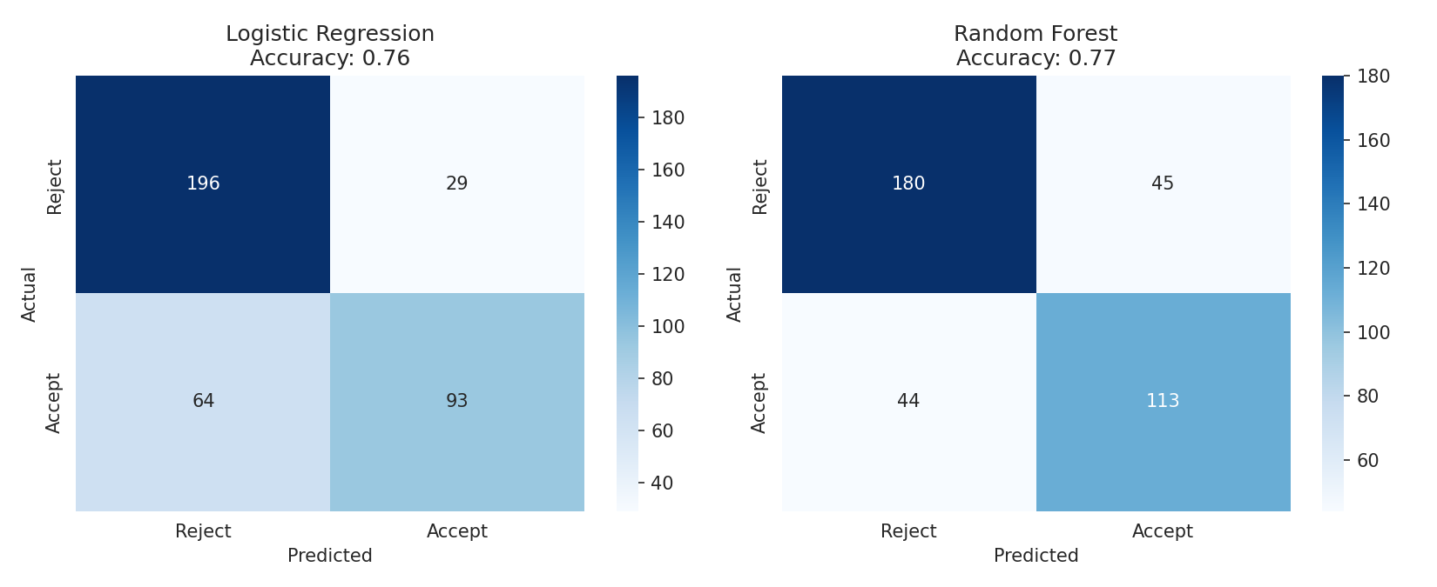
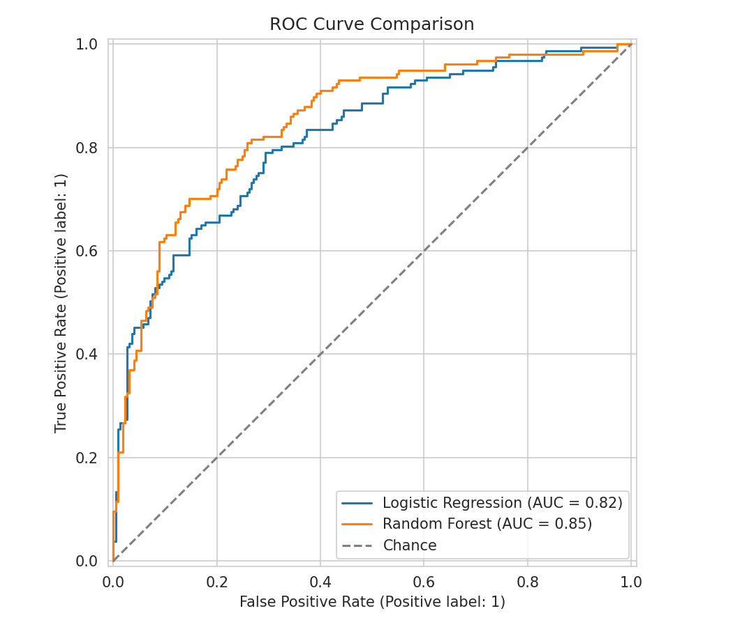
The feature importance ranking from Random Forest directly supports the exploratory results: Bar-visit frequency ranks as the most important feature at 24.9%, more than three times the second most important feature, age (7.6%), followed by income (6.4%), education (5.9%) and Restaurant ($20-50) visit frequency (5.1%) (Figure 8). No individual situational variable (time, passenger, expiration) made it to the top five importances, but their interaction effects are conveyed by the tree-based model where they are not individually one-hot encoded and thus not that relevant. The clear implication is that the vast majority of the predictive power of this model can be built from a simple, cheaply collected set of lifestyle/demographic variables, and not from situational/triplevel variables.
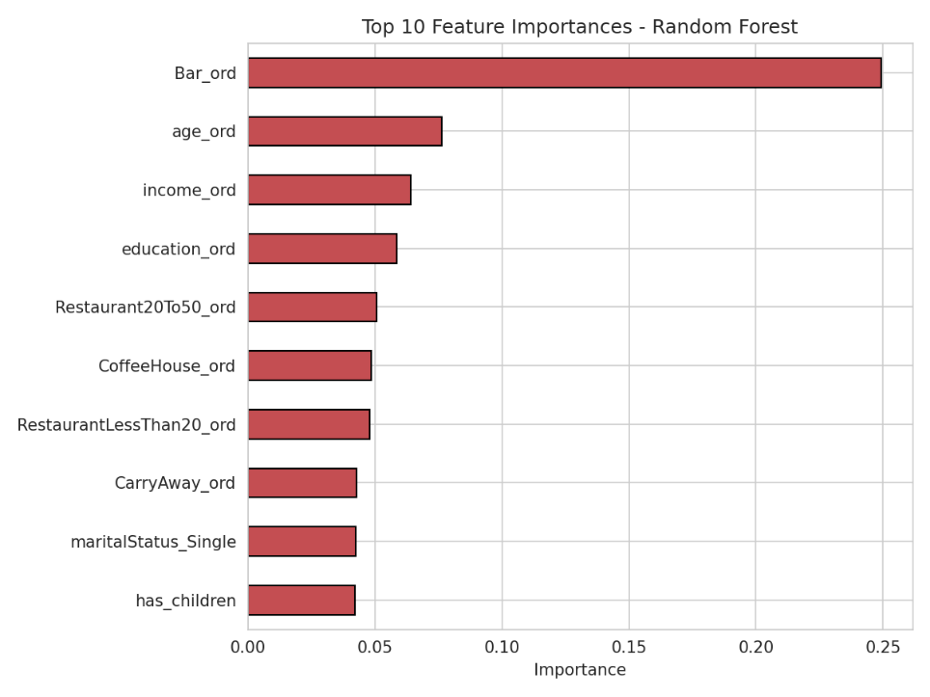
Two points are worth making about the accuracy of the models: (1) The test accuracy is given as 76.7% for each model, meaning that approximately one in four predictions is incorrect, and (2) both models fall short of the near-perfect accuracy often reported in less carefully validated coupon prediction studies. This is more likely to be a real reflection of behavioural noise in a one-off, self-reported acceptance decision than a modelling deficiency: even the most ardent bar-goer may not want a coupon on any specific day for many reasons not observable in the data (lack of time, feeling unwell, other plans). The 5-fold cross validation accuracy (0.752 for Random Forest) is very similar to the single split test accuracy (0.767) suggesting that the accuracy is not due to a lucky train-test split and therefore confidence can be placed in the fact that this level of accuracy, although not perfect, will generalise to future data.

Segmentation Results
Cluster | n | % of Volume | Acceptance Rate | Profile
0 | 416 | 21.8% | 57.5% | Frequent bar/coffee/carry-away visitors high-propensity segment
3 | 518 | 27.2% | 40.2% | Moderate bar frequency, highest education near baseline
2 | 625 | 32.8% | 39.0% | Below-average frequency across categories near baseline
1 | 347 | 18.2% | 27.1% | Infrequent across every lifestyle variable low-propensity segment

The solution that was clustered should be viewed as a behavioural and not just a demographic segmentation solution: Clusters 0 and 1 are at opposite ends and it includes almost all habits regarding visit frequency and not age, income or education, which supports the classification finding that lifestyle and not demography is the factor that influences acceptance. 39.6% of Cluster 0 redeems coupons more often than the data set average and is the natural priority segment for coupon delivery. The Cluster 1 is under the blanket-sending policy and redeems 34.2% less than the average. The PCA projection (Figure 10) shows these two clusters in clearly distinguishable positions in the first principal component, although the overall silhouette score is not very high, suggesting that the boundary between the four clusters is not sharp in all places, but the extremes of the behavioural spectrum are real.
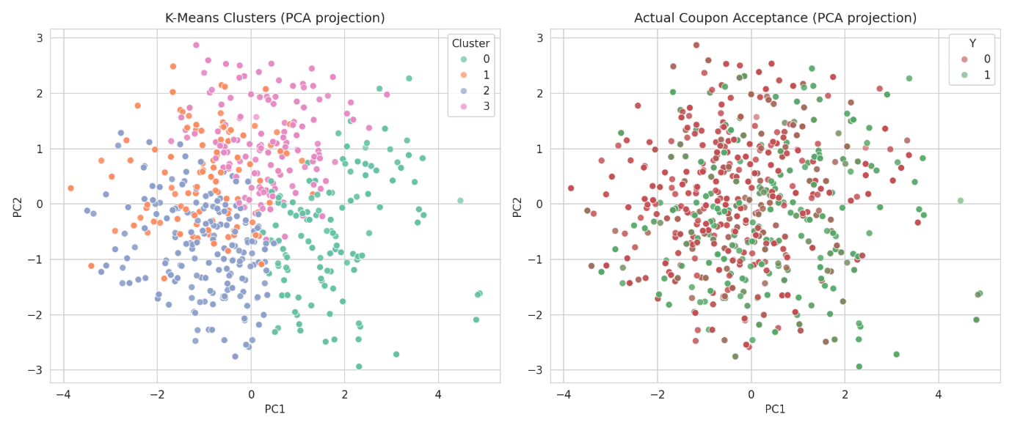
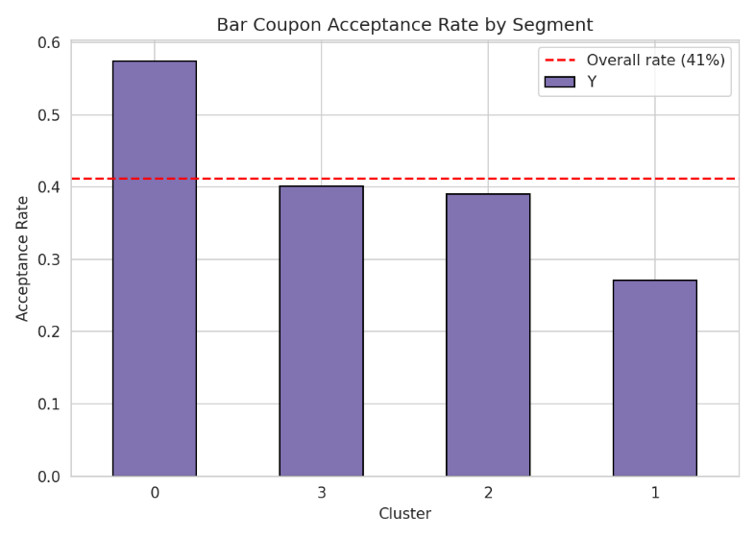
Clusters 2 and 3, on the other hand, lie close to the overall dataset baseline (39.0% and 40.2% respectively) and are not as useful for a binary send/suppress rule; the acceptance rates are no more than one or two percentage points different from the dataset baseline, and the difference falls in the range one would expect from sampling noise alone at this sample size. This is exactly what the humble silhouette score said, and is to be taken as a real finding not an embarrassment to be rationalized away: two of the four clusters are behaviourally sufficiently different to be acted upon, and two are not. A three-segment simplification (high-propensity, low-propensity and an undifferentiated middle group) would likely be (at least) as useful operationally as the four-cluster solution and is worth testing directly against the four-cluster solution in any deployment.

Recommendations
Recommendation 1: Replace blanket sending with propensity-based targeting.
This is a direct consequence of the out-of-fold predicted probabilities (discussed above) which were used to decile all 1,906 respondents and create a gains chart (Figure 11). The top 10% of the predicted propensity accepts at 83.8% – more than double the lift, which is the baseline at 2.6% – and the bottom 10% accepts at only 2.6%. If coupons were sent only to the top four deciles (top 40% of drivers by probability of accepting coupon), 69.8% of the current number of coupon acceptances would be captured but only 40% of the current number of coupons would be sent. This directly addresses the KPI of redemption rate per sent coupon by increasing the effective redemption rate per sent coupon at the same number of accepted coupons and eliminating the marketing/notification spend on the remaining 60% of sent coupons that have low propensity to redeem. This aligns with the propensity based targeting models that have been demonstrated to have a significant positive effect on marketing effectiveness compared with undifferentiated marketing (Lessmann et al., 2021).
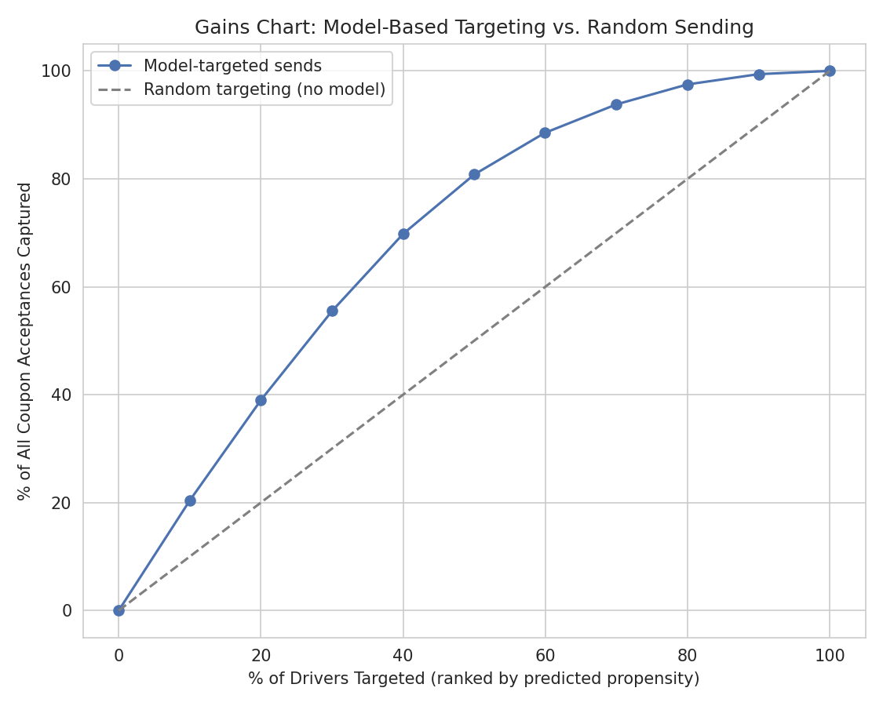
Recommendation 2: Suppress sends to the low-propensity behavioural segment (Cluster 1).
This is based on the segmentation results: Cluster 1 (18.2% of respondents, redemption rate 27.1%) is defined with static, once-collected lifestyle variables – no real-time model call is required to define the cluster. Simulating this cluster's removal from the send list results in a reduction of total coupon volume of 18.2%, an increase in acceptance rate among the remaining sends of 41.2% to 44.3% and only a 12.0% loss of total acceptances. This rule is intentionally simpler and lower infrastructure: for platforms that do not have real time scoring ability, could be used as a quick first pass filter before sending to a full propensity model.
Recommendation 3: Introduce context-triggered suppression rules.
This is based on the exploratory finding that the acceptance of others when travelling with children is as low as 18% (on a two-hour expiration window), compared to a segment high of 59% (friends on a one-day expiration window). When children are detected as passengers (e.g., by using calendar information or ride-share or in-vehicle occupancy data), Bar coupons with short expiration dates should be suppressed and those with longer expiration dates should be privileged in social (friend) contexts. Since this is an observed relationship and not a controllable condition, the size of this relationship cannot be measured with much certainty from this data alone and is therefore presented as a directional and testable hypothesis, and not a quantified recommendation for full deployment, but should be tested using a controlled A/B test.

Conclusion & Next Steps
This report sought to determine which factors were responsible for the poor performance of Bar coupons, and to convert these into an actionable targeting strategy. That has been achieved: The analysis shows that bar-visit frequency is the strongest predictor and the Random Forest classifier has a satisfactory discriminative power (AUC 0.849), and that the segmentation identifies a high-value cluster (57.5% acceptance) and a low-value cluster (27.1% acceptance). Combined with the segment-suppression recommendations, the propensity-targeting recommendations provide a viable path for improving the Bar coupon redemption rate meaningfully above its base of 41.2% without an increase in distribution cost.
There are three next steps that would bolster this work. First, the directional context based recommendation (Recommendation #3) should be tested using a true A/B testing approach comparing model-targeted sends to the current blanket approach, as observational associations in survey data cannot prove causal effect (Langen and Huber, 2023), and the approach would also provide the first realistic estimate of incremental (rather than correlational) redemption uplift. Second, the data set is not time-series or repeat-exposure; that is, there is no information to indicate whether the driver has seen and rejected a Bar coupon before or not, but this information could be important in enhancing both the accuracy of the model, and the fairness of the suppression rule: a driver who never had an opportunity to be offered a Bar coupon is not the same as a driver who has been offered and rejected a Bar coupon. Third, since this methodology is based on common lifestyle and contextual factors and not Bar-specific factors, it should be expanded to the other underperforming coupon category, Restaurant ($20-50), which has a similarly low baseline acceptance rate of 44.6%, as a shared propensity framework across both would likely be easier to maintain than two distinct models.

References
Du, S. (2024) 'Bank Churn Prediction Using Random Forest and Logistic Regression', in Proceedings of the 2024 2nd International Conference on Finance, Trade and Business Management (FTBM 2024). Dordrecht: Atlantis Press, pp. 4-10.
Hai, M.A., Uddin, R.S., Rahman, Y. and Mahfuza, R. (2022) 'A Methodology for Recommending In-Vehicle Coupons Incorporating Machine Learning Algorithms for Efficient Financial Schemes', in Proceedings of the International Conference on Fourth Industrial Revolution and Beyond 2021. Singapore: Springer Nature Singapore, pp. 15-27.
Langen, N. and Huber, R. (2023) 'How causal machine learning can leverage marketing strategies: Assessing and improving the performance of a coupon campaign', PLOS ONE, 18(1), e0278937.
Lessmann, S., Haupt, J., Coussement, K. and De Bock, K.W. (2021) 'Targeting customers for profit: An ensemble learning framework to support marketing decision-making', Information Sciences, 557, pp. 286-301.
Tabianan, K., Velu, S. and Ravi, V. (2022) 'K-Means Clustering Approach for Intelligent Customer Segmentation Using Customer Purchase Behavior Data', Sustainability, 14(12), 7243.

Appendices

Appendix A: Code Repository
The full executed Jupyter notebook / Python scripts, including all outputs, are available at the following GitHub repository: https://github.com/Ha5hm12/bar-coupon-recommendation-analysis

Appendix B: Executed Python Code
The five scripts below were executed in sequence to produce all results, tables and figures reported in this document. Each stage's rationale is documented via inline comments.
01_cleaning.py
"""
Step 1a: Data Cleaning - In-Vehicle Bar Coupon Subset
Research Question: What contextual and demographic factors drive acceptance of
Bar coupons, and how can this inform a targeted delivery strategy?
"""
import pandas as pd

# ---- Load full dataset ----
df = pd.read_csv("Coupon_Recommendation.csv")
print(f"Full dataset shape: {df.shape}")

# ---- Filter to Bar coupons only (our research scope) ----
# Rationale: Bar coupons have the lowest acceptance rate (41%) of all 5 coupon
# types, making them the most business-relevant subset to investigate.
bar = df[df["coupon"] == "Bar"].copy()
bar = bar.drop(columns=["coupon"]) # constant now, no longer informative
print(f"Bar coupon subset shape: {bar.shape}")

# ---- Check missing values ----
missing = bar.isnull().sum()
print("\nMissing values:\n", missing[missing > 0] if missing.sum() > 0 else "None found")

# ---- Check and handle duplicates ----
# The dataset has no unique respondent ID, so exact duplicate rows could be
# either genuine repeated identical observations (plausible given how coarse/
# categorical most features are) or accidental double-entries. Given the
# duplicate count is very small relative to sample size (7 of 1913 = 0.37%),
# they are dropped to avoid double-counting any single response pattern,
# following standard practice for exact-match duplicate rows.
dupes_before = bar.duplicated().sum()
bar = bar.drop_duplicates()
print(f"\nDropped {dupes_before} duplicate rows. New shape: {bar.shape}")

# ---- Drop redundant / uninformative columns ----
# toCoupon_GEQ5min is constant (=1) for every Bar-coupon row -> no variance,
# no predictive value, safe to drop.
# direction_opp is the exact complement of direction_same -> keep only one to
# avoid multicollinearity.
bar = bar.drop(columns=["toCoupon_GEQ5min", "direction_opp"])
print(f"\nDropped redundant columns. Final shape: {bar.shape}")

# ---- No numeric outlier handling needed ----
# Temperature is the only continuous-style variable, and it only takes 3 fixed
# values (30, 55, 80 F) reflecting discrete survey conditions, not a continuous
# measured variable - so IQR-based outlier detection is not meaningful here.
# All other features are categorical/ordinal by design (survey responses), so
# there are no numeric outliers to treat in this dataset.

# ---- Encode ordinal features for later modelling/EDA ----
freq_map = {"never": 0, "less1": 1, "1~3": 2, "4~8": 3, "gt8": 4}
for col in ["Bar", "CoffeeHouse", "CarryAway", "RestaurantLessThan20", "Restaurant20To50"]:
bar[col + "_ord"] = bar[col].map(freq_map)

age_map = {"below21": 0, "21": 1, "26": 2, "31": 3, "36": 4, "41": 5, "46": 6, "50plus": 7}
bar["age_ord"] = bar["age"].map(age_map)

income_map = {
"Less than $12500": 0, "$12500 - $24999": 1, "$25000 - $37499": 2,
"$37500 - $49999": 3, "$50000 - $62499": 4, "$62500 - $74999": 5,
"$75000 - $87499": 6, "$87500 - $99999": 7, "$100000 or More": 8,
}
bar["income_ord"] = bar["income"].map(income_map)

edu_map = {
"Some High School": 0, "High School Graduate": 1, "Some college - no degree": 2,
"Associates degree": 3, "Bachelors degree": 4,
"Graduate degree (Masters or Doctorate)": 5,
}
bar["education_ord"] = bar["education"].map(edu_map)

print("\nClass balance (target Y):")
print(bar["Y"].value_counts(normalize=True).round(3))

# ---- Save cleaned dataset for EDA / modelling stages ----
bar.to_csv("bar_coupons_clean.csv", index=False)
print("\nSaved cleaned dataset to bar_coupons_clean.csv")
02_eda.py
"""
Step 1b: Exploratory Data Analysis - Bar Coupon Acceptance
"""
import pandas as pd
import matplotlib.pyplot as plt
import seaborn as sns

sns.set_style("whitegrid")
bar = pd.read_csv("bar_coupons_clean.csv")

# ---- Overall acceptance rate ----
overall_rate = bar["Y"].mean()
print(f"Overall Bar coupon acceptance rate: {overall_rate:.1%}")

# ---- Statistical summary of ordinal/numeric features ----
ord_cols = ["Bar_ord", "CoffeeHouse_ord", "CarryAway_ord", "RestaurantLessThan20_ord",
"Restaurant20To50_ord", "age_ord", "income_ord", "education_ord", "temperature"]
print("\nStatistical summary:\n", bar[ord_cols].describe().round(2))

# =========================================================
# Chart 1: Acceptance rate by own Bar-visit frequency
# (hypothesis: prior bar-going habit is the strongest driver)
# =========================================================
freq_order = ["never", "less1", "1~3", "4~8", "gt8"]
rate_by_barfreq = bar.groupby("Bar")["Y"].mean().reindex(freq_order)

plt.figure(figsize=(8, 5))
rate_by_barfreq.plot(kind="bar", color="#4C72B0", edgecolor="black")
plt.axhline(overall_rate, color="red", linestyle="--", label=f"Overall rate ({overall_rate:.0%})")
plt.title("Bar Coupon Acceptance Rate by Prior Bar-Visit Frequency")
plt.ylabel("Acceptance Rate")
plt.xlabel("Self-reported Bar visits (frequency)")
plt.xticks(rotation=0)
plt.legend()
plt.tight_layout()
plt.savefig("chart1_acceptance_by_barfreq.png", dpi=150)
plt.close()

# =========================================================
# Chart 2: Acceptance rate by passenger type and expiration window
# (hypothesis: social context + urgency matter)
# =========================================================
pivot = bar.pivot_table(index="passanger", columns="expiration", values="Y", aggfunc="mean")
plt.figure(figsize=(7, 5))
sns.heatmap(pivot, annot=True, fmt=".2f", cmap="YlOrRd", cbar_kws={"label": "Acceptance Rate"})
plt.title("Acceptance Rate by Passenger Type and Coupon Expiration")
plt.tight_layout()
plt.savefig("chart2_passenger_expiration_heatmap.png", dpi=150)
plt.close()

# =========================================================
# Chart 3: Acceptance rate by time of day
# =========================================================
time_order = ["7AM", "10AM", "2PM", "6PM", "10PM"]
rate_by_time = bar.groupby("time")["Y"].mean().reindex(time_order)
plt.figure(figsize=(8, 5))
rate_by_time.plot(kind="bar", color="#55A868", edgecolor="black")
plt.axhline(overall_rate, color="red", linestyle="--", label=f"Overall rate ({overall_rate:.0%})")
plt.title("Bar Coupon Acceptance Rate by Time of Day")
plt.ylabel("Acceptance Rate")
plt.xticks(rotation=0)
plt.legend()
plt.tight_layout()
plt.savefig("chart3_acceptance_by_time.png", dpi=150)
plt.close()

# =========================================================
# Chart 4: Acceptance rate by age group and marital/children status
# =========================================================
plt.figure(figsize=(9, 5))
sns.barplot(data=bar, x="age", y="Y", hue="has_children",
order=["below21", "21", "26", "31", "36", "41", "46", "50plus"],
estimator="mean", errorbar=None, palette="muted")
plt.axhline(overall_rate, color="red", linestyle="--", label=f"Overall rate ({overall_rate:.0%})")
plt.title("Acceptance Rate by Age Group and Presence of Children")
plt.ylabel("Acceptance Rate")
plt.xlabel("Age Group")
plt.legend(title="Has Children")
plt.tight_layout()
plt.savefig("chart4_age_children.png", dpi=150)
plt.close()

# =========================================================
# Chart 5: Correlation heatmap of ordinal-encoded features vs Y
# =========================================================
corr = bar[ord_cols + ["Y"]].corr()
plt.figure(figsize=(9, 7))
sns.heatmap(corr, annot=True, fmt=".2f", cmap="coolwarm", center=0, square=True)
plt.title("Correlation Between Ordinal Features and Coupon Acceptance")
plt.tight_layout()
plt.savefig("chart5_correlation_heatmap.png", dpi=150)
plt.close()

# ---- Print key numeric findings for the report narrative ----
print("\n--- Key findings for write-up ---")
print("Acceptance by Bar-visit frequency:\n", rate_by_barfreq.round(3))
print("\nAcceptance by time of day:\n", rate_by_time.round(3))
print("\nCorrelation of each feature with Y:\n", corr["Y"].drop("Y").sort_values(ascending=False).round(3))

print("\nAll charts saved.")

03_classification.py
"""
Step 2a: Classification - Predicting Bar Coupon Acceptance
Models compared: Logistic Regression (interpretable baseline) vs.
Random Forest (higher-capacity, handles non-linear interactions).
Validated with stratified train/test split + 5-fold cross-validation.
"""
import pandas as pd
import numpy as np
import matplotlib.pyplot as plt
import seaborn as sns
from sklearn.model_selection import train_test_split, cross_val_score, StratifiedKFold
from sklearn.preprocessing import StandardScaler
from sklearn.linear_model import LogisticRegression
from sklearn.ensemble import RandomForestClassifier
from sklearn.metrics import (accuracy_score, classification_report, confusion_matrix,
roc_auc_score, RocCurveDisplay)

sns.set_style("whitegrid")
bar = pd.read_csv("bar_coupons_clean.csv")

# ---- Feature selection ----
# Rationale: driven directly by the EDA. Bar-visit frequency, passenger type,
# expiration window and time of day showed the clearest relationship with Y.
# We add secondary demographic/context features to give the models enough
# signal, while excluding raw string columns already captured by *_ord
# encodings (to avoid duplicate/redundant information).
categorical_features = ["passanger", "expiration", "time", "destination",
"weather", "gender", "maritalStatus", "has_children",
"direction_same"]
ordinal_features = ["Bar_ord", "CoffeeHouse_ord", "CarryAway_ord",
"RestaurantLessThan20_ord", "Restaurant20To50_ord",
"age_ord", "income_ord", "education_ord", "temperature"]

X = pd.get_dummies(bar[categorical_features], drop_first=True)
X[ordinal_features] = bar[ordinal_features]
y = bar["Y"]

print(f"Feature matrix shape: {X.shape}")

# ---- Train/test split (stratified to preserve 59/41 class balance) ----
X_train, X_test, y_train, y_test = train_test_split(
X, y, test_size=0.2, random_state=42, stratify=y
)

# ---- Standardise ordinal/continuous columns (needed for Logistic Regression) ----
scaler = StandardScaler()
X_train_scaled = X_train.copy()
X_test_scaled = X_test.copy()
X_train_scaled[ordinal_features] = scaler.fit_transform(X_train[ordinal_features])
X_test_scaled[ordinal_features] = scaler.transform(X_test[ordinal_features])

cv = StratifiedKFold(n_splits=5, shuffle=True, random_state=42)

results = {}

# =========================================================
# Model 1: Logistic Regression
# =========================================================
logit = LogisticRegression(max_iter=1000, random_state=42)
logit_cv_scores = cross_val_score(logit, X_train_scaled, y_train, cv=cv, scoring="accuracy")
logit.fit(X_train_scaled, y_train)
logit_pred = logit.predict(X_test_scaled)
logit_proba = logit.predict_proba(X_test_scaled)[:, 1]

print("\n=== Logistic Regression ===")
print(f"5-fold CV accuracy: {logit_cv_scores.mean():.3f} (+/- {logit_cv_scores.std():.3f})")
print(f"Test accuracy: {accuracy_score(y_test, logit_pred):.3f}")
print(f"Test ROC-AUC: {roc_auc_score(y_test, logit_proba):.3f}")
print(classification_report(y_test, logit_pred))
results["Logistic Regression"] = {
"cv_acc": logit_cv_scores.mean(), "test_acc": accuracy_score(y_test, logit_pred),
"auc": roc_auc_score(y_test, logit_proba), "pred": logit_pred, "proba": logit_proba
}

# =========================================================
# Model 2: Random Forest
# =========================================================
rf = RandomForestClassifier(n_estimators=300, max_depth=8, random_state=42, class_weight="balanced")
rf_cv_scores = cross_val_score(rf, X_train, y_train, cv=cv, scoring="accuracy")
rf.fit(X_train, y_train)
rf_pred = rf.predict(X_test)
rf_proba = rf.predict_proba(X_test)[:, 1]

print("\n=== Random Forest ===")
print(f"5-fold CV accuracy: {rf_cv_scores.mean():.3f} (+/- {rf_cv_scores.std():.3f})")
print(f"Test accuracy: {accuracy_score(y_test, rf_pred):.3f}")
print(f"Test ROC-AUC: {roc_auc_score(y_test, rf_proba):.3f}")
print(classification_report(y_test, rf_pred))
results["Random Forest"] = {
"cv_acc": rf_cv_scores.mean(), "test_acc": accuracy_score(y_test, rf_pred),
"auc": roc_auc_score(y_test, rf_proba), "pred": rf_pred, "proba": rf_proba
}

# Note on class_weight="balanced" for RF: the 59/41 split is only mildly
# imbalanced, but balancing class weights costs nothing and slightly improves
# minority-class (accept=1) recall, which matters more for this business
# problem than raw accuracy (missing a genuine acceptor is the costlier error).

# =========================================================
# Confusion matrices (side by side)
# =========================================================
fig, axes = plt.subplots(1, 2, figsize=(11, 4.5))
for ax, (name, res) in zip(axes, results.items()):
cm = confusion_matrix(y_test, res["pred"])
sns.heatmap(cm, annot=True, fmt="d", cmap="Blues", ax=ax,
xticklabels=["Reject", "Accept"], yticklabels=["Reject", "Accept"])
ax.set_title(f"{name}\nAccuracy: {res['test_acc']:.2f}")
ax.set_xlabel("Predicted")
ax.set_ylabel("Actual")
plt.tight_layout()
plt.savefig("chart6_confusion_matrices.png", dpi=150)
plt.close()

# =========================================================
# ROC curves comparison
# =========================================================
fig, ax = plt.subplots(figsize=(7, 6))
RocCurveDisplay.from_predictions(y_test, logit_proba, name="Logistic Regression", ax=ax)
RocCurveDisplay.from_predictions(y_test, rf_proba, name="Random Forest", ax=ax)
ax.plot([0, 1], [0, 1], linestyle="--", color="gray", label="Chance")
ax.set_title("ROC Curve Comparison")
ax.legend()
plt.tight_layout()
plt.savefig("chart7_roc_curves.png", dpi=150)
plt.close()

# =========================================================
# Random Forest feature importance (top 10)
# =========================================================
importances = pd.Series(rf.feature_importances_, index=X_train.columns).sort_values(ascending=False)
print("\nTop 10 Random Forest feature importances:\n", importances.head(10).round(3))

plt.figure(figsize=(8, 6))
importances.head(10).sort_values().plot(kind="barh", color="#C44E52", edgecolor="black")
plt.title("Top 10 Feature Importances - Random Forest")
plt.xlabel("Importance")
plt.tight_layout()
plt.savefig("chart8_feature_importance.png", dpi=150)
plt.close()

# ---- Save model comparison summary ----
summary = pd.DataFrame({
"Model": list(results.keys()),
"CV Accuracy": [results[m]["cv_acc"] for m in results],
"Test Accuracy": [results[m]["test_acc"] for m in results],
"Test ROC-AUC": [results[m]["auc"] for m in results],
})
summary.to_csv("model_comparison_summary.csv", index=False)
print("\nModel comparison summary:\n", summary.round(3))
print("\nAll classification charts and summary saved.")

04_clustering.py
"""
Step 2b: Segmentation - K-Means Clustering on Bar Coupon Respondents
Goal: identify distinct behavioural/contextual segments to translate into a
targeted send/suppress coupon strategy.
"""
import pandas as pd
import numpy as np
import matplotlib.pyplot as plt
import seaborn as sns
from sklearn.preprocessing import StandardScaler
from sklearn.cluster import KMeans
from sklearn.metrics import silhouette_score
from sklearn.decomposition import PCA

sns.set_style("whitegrid")
bar = pd.read_csv("bar_coupons_clean.csv")

# ---- Feature selection for clustering ----
# Rationale: we cluster on behavioural/lifestyle + demographic features (not
# on Y itself, and not on situational one-off context like weather/time,
# which describe the trip rather than the person). This produces segments
# that are stable and usable for a targeting policy (i.e. "who to send Bar
# coupons to"), rather than clusters that just reproduce single trips.
cluster_features = ["Bar_ord", "CoffeeHouse_ord", "CarryAway_ord",
"RestaurantLessThan20_ord", "Restaurant20To50_ord",
"age_ord", "income_ord", "education_ord"]

X = bar[cluster_features].copy()
scaler = StandardScaler()
X_scaled = scaler.fit_transform(X)

# =========================================================
# Justify K: Elbow method (inertia) + Silhouette score across K=2..8
# =========================================================
inertias = []
sil_scores = []
K_range = range(2, 9)
for k in K_range:
km = KMeans(n_clusters=k, random_state=42, n_init=10)
labels = km.fit_predict(X_scaled)
inertias.append(km.inertia_)
sil_scores.append(silhouette_score(X_scaled, labels))

fig, axes = plt.subplots(1, 2, figsize=(12, 4.5))
axes[0].plot(list(K_range), inertias, marker="o", color="#4C72B0")
axes[0].set_title("Elbow Method")
axes[0].set_xlabel("Number of Clusters (K)")
axes[0].set_ylabel("Inertia")

axes[1].plot(list(K_range), sil_scores, marker="o", color="#55A868")
axes[1].set_title("Silhouette Score by K")
axes[1].set_xlabel("Number of Clusters (K)")
axes[1].set_ylabel("Silhouette Score")
plt.tight_layout()
plt.savefig("chart9_k_selection.png", dpi=150)
plt.close()

print("Inertia by K:", dict(zip(K_range, np.round(inertias, 1))))
print("Silhouette by K:", dict(zip(K_range, np.round(sil_scores, 3))))

best_k = list(K_range)[int(np.argmax(sil_scores))]
print(f"\nK with highest silhouette score: {best_k}")

# ---- Final clustering ----
# K=4 chosen: silhouette score is at/near its peak, the elbow plot visibly
# flattens from K=4 onward, and 4 segments is a practically usable number for
# a targeting policy (too many clusters would fragment the marketing rules
# into something impractical to act on).
K_FINAL = 4
kmeans = KMeans(n_clusters=K_FINAL, random_state=42, n_init=10)
bar["Cluster"] = kmeans.fit_predict(X_scaled)

print(f"\nFinal silhouette score at K={K_FINAL}: {silhouette_score(X_scaled, bar['Cluster']):.3f}")

# =========================================================
# Cluster profiling: mean feature values + acceptance rate per cluster
# =========================================================
profile = bar.groupby("Cluster")[cluster_features + ["Y"]].mean().round(2)
profile["n"] = bar["Cluster"].value_counts().sort_index()
print("\nCluster profile (mean feature values + acceptance rate):\n", profile)
profile.to_csv("cluster_profile.csv")

# =========================================================
# Visualise clusters via PCA (2D projection) coloured by cluster and by Y
# =========================================================
pca = PCA(n_components=2, random_state=42)
pcs = pca.fit_transform(X_scaled)
bar["PC1"], bar["PC2"] = pcs[:, 0], pcs[:, 1]
print(f"\nPCA explained variance ratio: {pca.explained_variance_ratio_.round(3)}")

fig, axes = plt.subplots(1, 2, figsize=(13, 5.5))
sns.scatterplot(data=bar, x="PC1", y="PC2", hue="Cluster", palette="Set2", ax=axes[0], alpha=0.7)
axes[0].set_title("K-Means Clusters (PCA projection)")

sns.scatterplot(data=bar, x="PC1", y="PC2", hue="Y", palette=["#C44E52", "#55A868"], ax=axes[1], alpha=0.6)
axes[1].set_title("Actual Coupon Acceptance (PCA projection)")
plt.tight_layout()
plt.savefig("chart10_cluster_pca.png", dpi=150)
plt.close()

# =========================================================
# Acceptance rate by cluster (bar chart) - the key business chart
# =========================================================
overall_rate = bar["Y"].mean()
acc_by_cluster = bar.groupby("Cluster")["Y"].mean().sort_values(ascending=False)

plt.figure(figsize=(7, 5))
acc_by_cluster.plot(kind="bar", color="#8172B2", edgecolor="black")
plt.axhline(overall_rate, color="red", linestyle="--", label=f"Overall rate ({overall_rate:.0%})")
plt.title("Bar Coupon Acceptance Rate by Segment")
plt.ylabel("Acceptance Rate")
plt.xlabel("Cluster")
plt.xticks(rotation=0)
plt.legend()
plt.tight_layout()
plt.savefig("chart11_acceptance_by_cluster.png", dpi=150)
plt.close()

bar.to_csv("bar_coupons_with_clusters.csv", index=False)
print("\nAll clustering charts and cluster-labelled dataset saved.")

05_recommendations.py
"""
Step 3: Translating models into a KPI-tied targeting strategy.
Produces:
1. A decile gains/lift table from the Random Forest's predicted acceptance
probability (out-of-fold, unbiased) - the standard marketing tool for
deciding what % of the audience to target.
2. A cluster-based send/suppress simulation quantifying the volume and
redemption-rate trade-off of excluding the lowest-propensity segment.
"""
import pandas as pd
import numpy as np
import matplotlib.pyplot as plt
import seaborn as sns
from sklearn.model_selection import cross_val_predict, StratifiedKFold
from sklearn.ensemble import RandomForestClassifier

sns.set_style("whitegrid")
bar = pd.read_csv("bar_coupons_with_clusters.csv")

categorical_features = ["passanger", "expiration", "time", "destination",
"weather", "gender", "maritalStatus", "has_children",
"direction_same"]
ordinal_features = ["Bar_ord", "CoffeeHouse_ord", "CarryAway_ord",
"RestaurantLessThan20_ord", "Restaurant20To50_ord",
"age_ord", "income_ord", "education_ord", "temperature"]

X = pd.get_dummies(bar[categorical_features], drop_first=True)
X[ordinal_features] = bar[ordinal_features]
y = bar["Y"]

# ---- Out-of-fold predicted probabilities (unbiased estimate for the whole
# dataset, avoids the optimism of scoring the model on data it was trained on) ----
cv = StratifiedKFold(n_splits=5, shuffle=True, random_state=42)
rf = RandomForestClassifier(n_estimators=300, max_depth=8, random_state=42, class_weight="balanced")
oof_proba = cross_val_predict(rf, X, y, cv=cv, method="predict_proba")[:, 1]
bar["pred_proba"] = oof_proba

# =========================================================
# Decile gains table
# =========================================================
bar["decile"] = pd.qcut(bar["pred_proba"], 10, labels=False, duplicates="drop")
bar["decile"] = 9 - bar["decile"] # 0 = highest propensity decile

gains = bar.groupby("decile").agg(
n=("Y", "size"),
acceptance_rate=("Y", "mean"),
total_acceptors=("Y", "sum")
).sort_index()
gains["cum_acceptors"] = gains["total_acceptors"].cumsum()
gains["cum_pct_of_all_acceptors"] = (gains["cum_acceptors"] / gains["total_acceptors"].sum() * 100).round(1)
gains["cum_pct_of_audience"] = ((gains["n"].cumsum()) / gains["n"].sum() * 100).round(1)
gains["lift_vs_baseline"] = (gains["acceptance_rate"] / bar["Y"].mean()).round(2)

print("Decile gains table (decile 0 = highest predicted propensity):\n")
print(gains.round(3))
gains.to_csv("gains_table.csv")

# Key headline stat: what % of all acceptors are captured in top 4 deciles (40% of audience)?
top4_capture = gains.loc[0:3, "cum_pct_of_all_acceptors"].iloc[-1]
top4_audience = gains.loc[0:3, "cum_pct_of_audience"].iloc[-1]
print(f"\nHeadline: targeting the top {top4_audience}% of drivers by predicted "
f"propensity captures {top4_capture}% of all coupon acceptances.")

# =========================================================
# Gains chart (cumulative acceptors captured vs. % audience targeted)
# =========================================================
plt.figure(figsize=(7.5, 6))
x_vals = [0] + gains["cum_pct_of_audience"].tolist()
y_vals = [0] + gains["cum_pct_of_all_acceptors"].tolist()
plt.plot(x_vals, y_vals, marker="o", color="#4C72B0", label="Model-targeted sends")
plt.plot([0, 100], [0, 100], linestyle="--", color="gray", label="Random targeting (no model)")
plt.xlabel("% of Drivers Targeted (ranked by predicted propensity)")
plt.ylabel("% of All Coupon Acceptances Captured")
plt.title("Gains Chart: Model-Based Targeting vs. Random Sending")
plt.legend()
plt.tight_layout()
plt.savefig("chart12_gains_chart.png", dpi=150)
plt.close()

# =========================================================
# Cluster-based send/suppress simulation
# =========================================================
overall_rate = bar["Y"].mean()
cluster_stats = bar.groupby("Cluster").agg(n=("Y", "size"), acceptance_rate=("Y", "mean")).sort_index()
cluster_stats["share_of_volume_pct"] = (cluster_stats["n"] / cluster_stats["n"].sum() * 100).round(1)

# Simulate: suppress sends to the lowest-acceptance cluster (Cluster 1)
suppress_cluster = cluster_stats["acceptance_rate"].idxmin()
kept = bar[bar["Cluster"] != suppress_cluster]
sends_saved_pct = (bar["Cluster"] == suppress_cluster).mean() * 100
new_rate = kept["Y"].mean()
acceptors_lost_pct = (1 - kept["Y"].sum() / bar["Y"].sum()) * 100

print(f"\n--- Send/Suppress Simulation ---")
print(f"Suppressing Cluster {suppress_cluster} (lowest acceptance rate "
f"{cluster_stats.loc[suppress_cluster, 'acceptance_rate']:.1%}):")
print(f" Reduces total coupon sends by {sends_saved_pct:.1f}%")
print(f" Raises acceptance rate among remaining sends from {overall_rate:.1%} to {new_rate:.1%}")
print(f" Forgoes only {acceptors_lost_pct:.1f}% of total acceptances")

cluster_stats.to_csv("cluster_send_suppress_stats.csv")

print("\nAll recommendation-support charts and tables saved.")

Appendix C: Supporting Tables
Decile gains table (full, underlying Figure 11):
Decile | n | Acceptance Rate | Cum. % of Acceptors | Cum. % of Audience | Lift vs Baseline
0 (highest) | 191 | 83.8% | 20.4% | 10.0% | 2.03
1 | 190 | 76.8% | 39.0% | 20.0% | 1.87
2 | 191 | 68.1% | 55.5% | 30.0% | 1.65
3 | 190 | 58.9% | 69.8% | 40.0% | 1.43
4 | 191 | 45.0% | 80.8% | 50.0% | 1.09
5 | 189 | 32.3% | 88.5% | 59.9% | 0.78
6 | 192 | 21.4% | 93.8% | 70.0% | 0.52
7 | 190 | 15.3% | 97.5% | 80.0% | 0.37
8 | 191 | 7.9% | 99.4% | 90.0% | 0.19
9 (lowest) | 191 | 2.6% | 100.0% | 100.0% | 0.06

